ĐỀ THI TIẾNG ANH Mã đề: 14
Trình độ A2
Họ và tên thí sinh: ……………..……………………………………………………….……………………………………………………………….
Số báo danh: ……………..…………………………………………...……. Phòng thi số: …………………………….…………………

PAPER TWO LISTENING (Approximately 15 minutes)
PART 1: Questions 1 – 5
You will hear five short conversations. You will hear each conversation twice. There is one question for each conversation. For each question, choose the right answer (A, B or C).
Example: Which is the girl’s first lesson this morning?
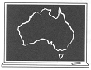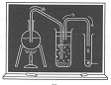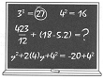
A □ √B □ C □

1. How much were the boy’s sunglasses?
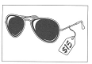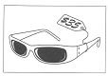
A □ B □ C □
2. Where is the nearest post office?
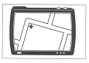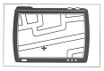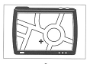
A □ B □ C □
3. What time did the girl wake up?
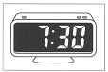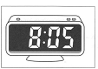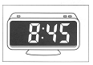
A □ B □ C □
4. What job would the boy like to do?
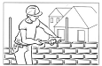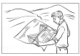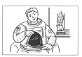
A □ B □ C □
5. What does Nada want her mum to buy?
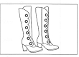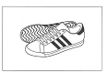
A □ B □ C □

PART 2: Questions 6-10
Listen to Helena and her father talking about her school trip. Which places will Helena visit? For questions 6-10, write a letter A-H next to each day. You will hear the conversation twice.
EXAMPLE | ANSWER
0 Monday | F
CLOTHES |  | PLACES
6 Tuesday  7 Wednesday  8 Thursday  9 Friday  10 Saturday |  | A Canal  B Castle  C farm  D hill  E island  F lake  G village  H woods

PART 3: Questions 11-15
Listen to Greg telling Anna about a drawing and writing competition.
For each question, choose the right answer (A, B, or C). You will hear the conversation twice.
Example: 0. You have to draw
√ A. a monster.
B. the moon.
C. a person.

11. You have to choose the monster’s
A. age
B. name
C. size
12. You have to write no more than
A. 50 words
B. 100 words
C. 150 words
13. To enter, you must be older than
A. 12.
B. 13.
C. 14.
14. The person who will choose the winner is
A. a writer.
B. a photographer.
C. an artist.
15. The first prize is
A. a school bag
B. some money
C. cinema tickets.

